Peter Julius M. Estacio
Grouped with:
Augusto Gabbriel M. Calilung
Rafael Luis Mari R. Lambo
ENGG 27.01 - M
February 5, 2026

Progress Report 2 for Project 1: Fixed-Point Approach for Finding Roots of Polynomials

As of February 5, 2026, major progress has been made on the project, including integration of is_int() and is_floating_pt() functions, header implementation, more robust file validation, and stricter user input validation.
Integration of is_int() and is_floating_pt() functions was necessary in validating the degree of the polynomial in the polynomial file and validating user input as a double-precision floating point number. As such, their corresponding headers and their implementation were added to the project.
From there, various program functions such as reading the polynomial file and calculating for the polynomial roots via the fixed-point approach were programmed separately from the main program through header implementation, compartmentalizing the program and making it more readable.
File validation was made more robust by fixing the functionality that a default file called ‘test’ would open should the user not input any polynomial file. Additionally, the program will continuously request for a polynomial file to open, should the user input an invalid polynomial file name or the program fail to open the user-inputted file.
Lastly, user input validation was implemented, specifically for the polynomial file as mentioned earlier and for the initial guess g(0). Due to the algebraic techniques used to derive g(x) as a rational function, the program will fail to return any results should the user input g(0) = 0. So, the program is will now continuously ask for a valid initial guess g(0) should the user input an invalid double-precision floating point number or 0.
Due to this progress, the program is largely complete. Further progress includes checking the program’s compliance with the detailed specifications.

` 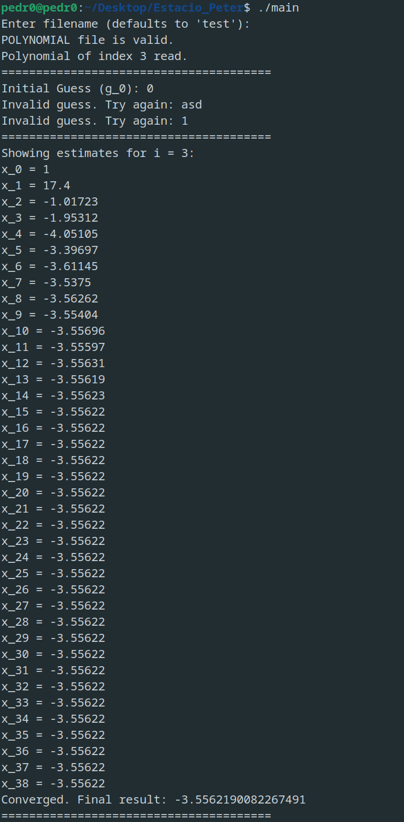 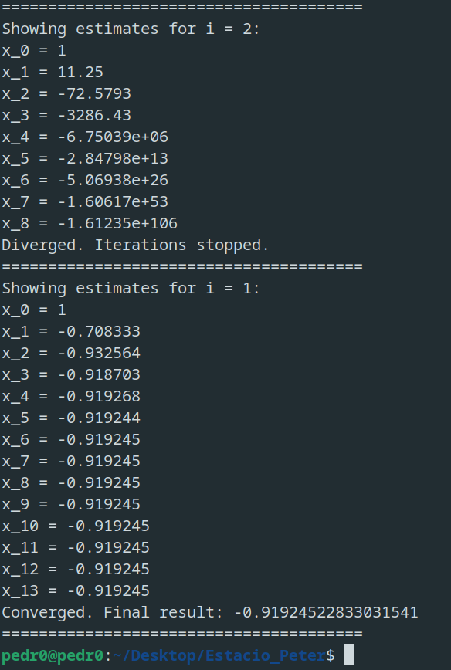
sample screenshots – program executable run and example results
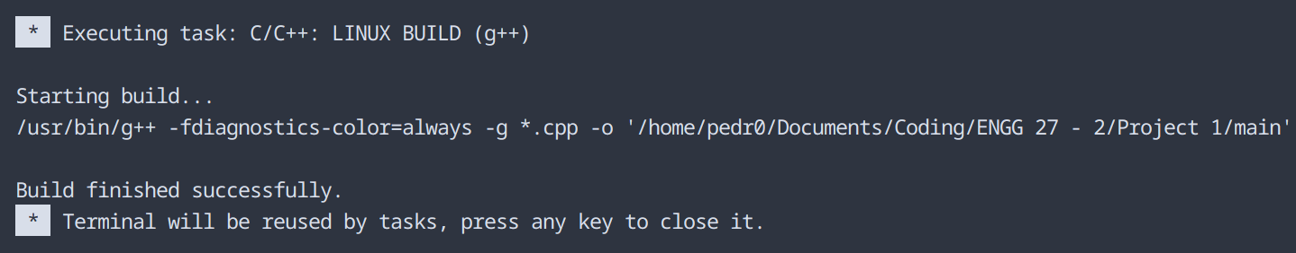
sample screenshot – compilation on Visual Studio Code
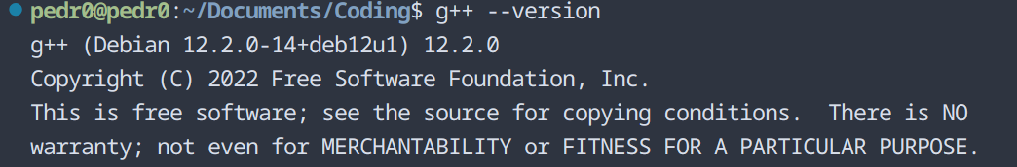
compiler version – g++ (Debian 12.2.0-14+deb12u1) 12.2.0
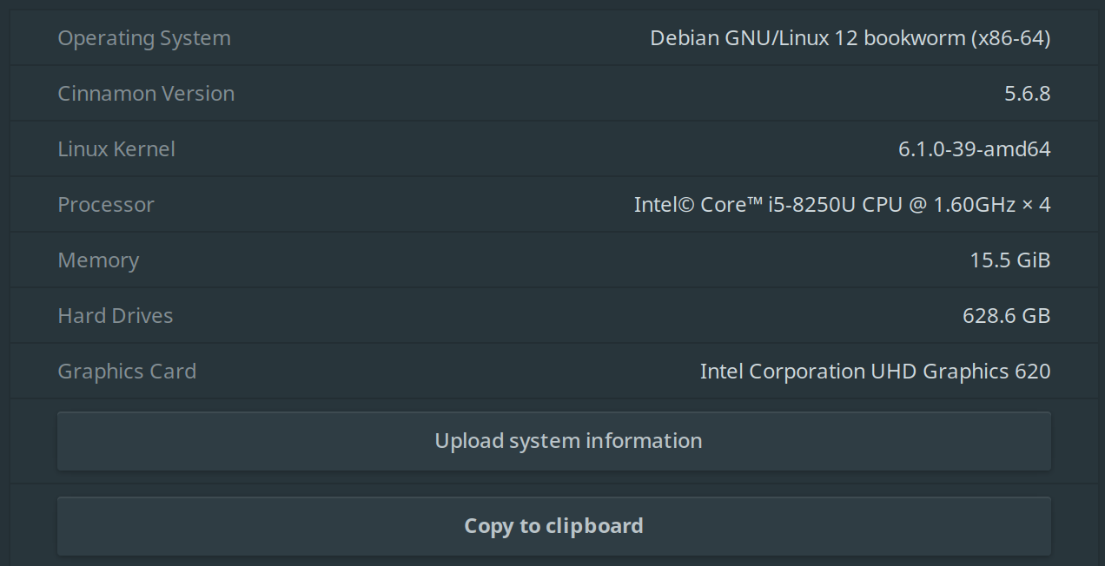
operating system – Debian 12 bookworm, Cinnamon version 5.6.8
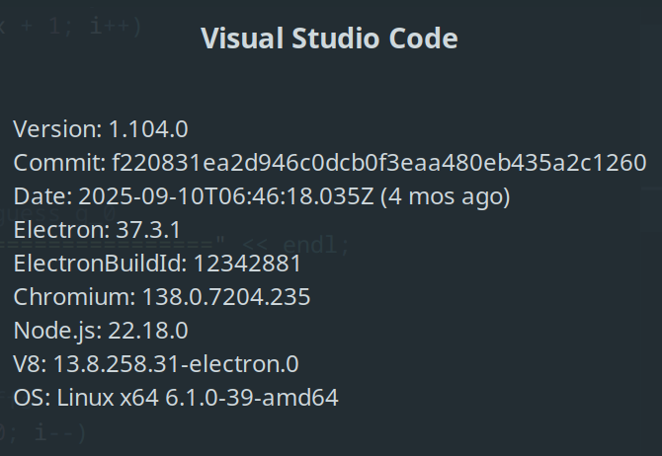
IDE – Visual Studio Code ver 1.104.0

